

**Agreement & Milestones for Health Chat Android App:**

This android project will take approximate **2- 3 months** to complete. The start date for the app development will be depend on the Client (Infinite Will Studio). In other word, the project can be started anytime with the preference of the client. After checking and signing this document, both parties (Client and Developer) are subjected to agreement.

**1) Reference App:**

https://play.google.com/store/apps/details?id=com.jaumo

**2) Overview:**

This health chat app project will be referencing to the app link above. It serves as an modern social networking app where users are able to chat, find, discuss and post topic about health with the world.

**3) Backend Server:**

We create backend server for this app using Amazon (http://quickblox.com/plans/)

**4) App Development Cost:**

- USD 2650 (App Development) + USD 294.44 (Odesk fees) + USD 40 (upfront payment)

- USD 2700 (Server Development) + USD 300 (Odesk fees)

**5) App Features:**

The health chat app contains functions such as the following:

* **Home Page** 
  + This is the home page to show to let users register or log into the health chat app.
* **Sign Up Page**
  + This is the welcome screen where first time user will sign up using facebook, twitter or email address.
* **Sign up with email page** 
  + This is the screen to let user sign up with email address.
* **Log In Page** 
  + In this page, users are able to key in existing email address account to log in.
* **Profile Page**
  + In the profile page, user can add photo, tag health topics, write about oneself, set yourself diagnosed with what disease.
  + Construct a "Like" button for people to like you.
  + Construct a "Message" button for people to have private chat.
* **Health Discussion Topics Section** 
  + Suggested - health discussion topic that are suggested by most people
  + All Topics - show all available health discussion topics in the server
  + Popular - show all the popular health discussion topics that most people discuss about it.
* **Health Discussion Chat Room** 
  + Users are able to write/post their own comments on a certain health topic.
  + Users are able to like, share, comment, and tag on each comment.
  + Users are able to like and tag the topic.
* **People** 
  + Suggested - Show suggested people to user around.
  + All People - Show all people that are using Health Chat App.
* **Favorite Page** 
  + People - Show favorite people in your list. Whenever user like a certain people, he/she will be added into the favorite list.
  + Discussion - Show favorite discussion in your list. Whenever user like a certain discussion topic, it will be added into the favorite list.
* **Messaging or Chat** 
  + User can choose anyone in the health chat list to have a private chat with him or her.
  + This will be involving messaging and chatting functions.

**6) Project Milestones:**

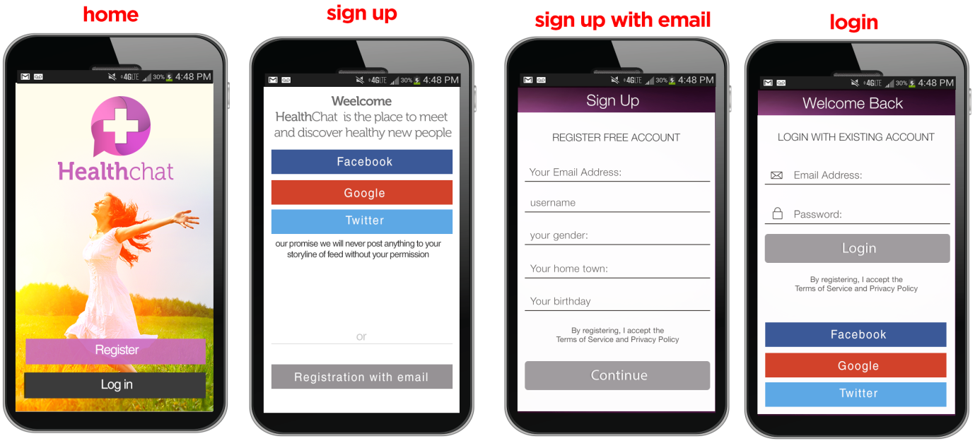

**Milestone 1:**

* Design all UI flow layout including the missing layout to see whole of UI.
* Create home page according to design.
* Develop the log in and sign up functions.
* Develop welcome back screen.
* Setup backend server and web services for log in.
* Setup facebook/twitter and email log in function.
* Develop function where user can retrieve their lost password (for those who sign up using email address).
* This milestone would cost **$ 300 (App)** + **$ 270 (Server side)**and it would take around **5-8 days** time.

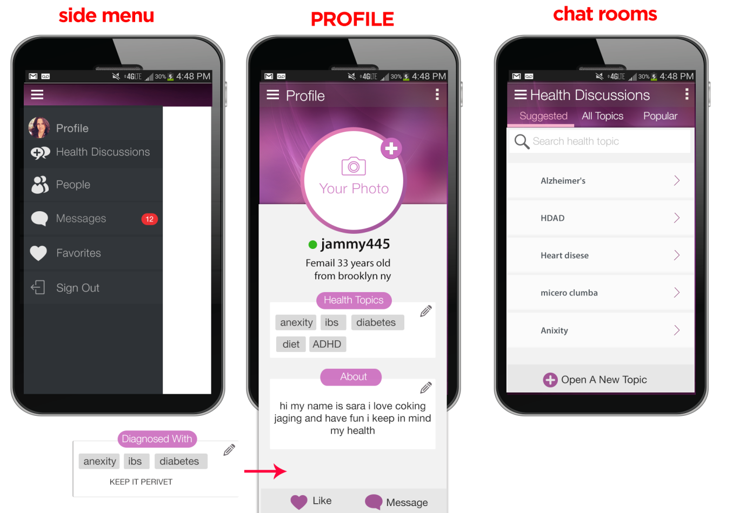

**Milestone 2:**

* Develop the side menu bar with items such as profile, health discussion, people, messages, favorites, and sign out.
* Design the Side Menu according to the above design.
* Design the Profile page to suit the above design (including all arrangements and structures).
* Develop **profile page,**  and create and setup the user algorithm to add profile photo and upload to backend server.
* Create health topic tags function, About, Diagnosed With, and buttons such as like button and message button.
* Design the Health Discussion page to suit the above design.
* Setup algorithm to open a new topic, search topic.
* Setup algorithm to suggested tab, all topic tab, and popular tab.
* All algorithms will be setup in the backend server and database also will be setting up.
* Create function in the top menu that users are able to block, delete and report others' profile (this will be applied to other people's profile).
* This milestone would cost **$ 500 (App)** + **$ 360 (Server side)**and it would take around **8-12 days** time.

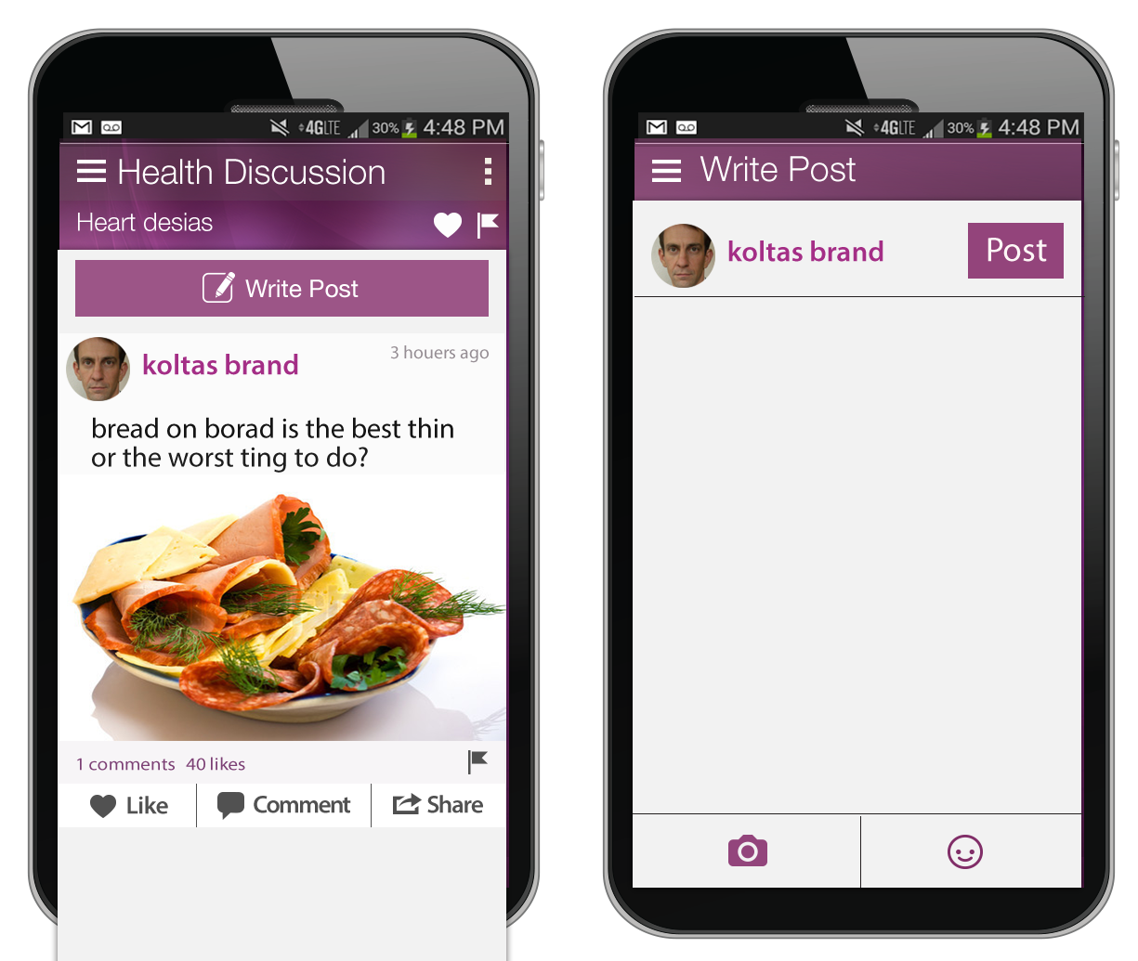

**Milestone 3:**

* **Health Discussion Chat Room** section page.
* Design the Health discussion chat room page to suit the above design.
* Create backend server section to support and store this section.
* First, create the topic like and tag buttons function and algorithm and communicate with the backend server.
* Second, create the "write post" function and also the upload image function with either camera or gallery.
* Create function to add "Smiley icons" into the message for posting.
* Third, setup the algorithm to let user share, like comment and tag on each and every single post.
* Each comment will show the number of comments left and the number of likes given by other users.
* Create function as when user click on the comment, there will be a pop up window showing all the comments left. (refer to facebook)
* This milestone would cost **$ 700 (App)** + **$ 720 (Server side)**and it would take around **9-15 days** time.

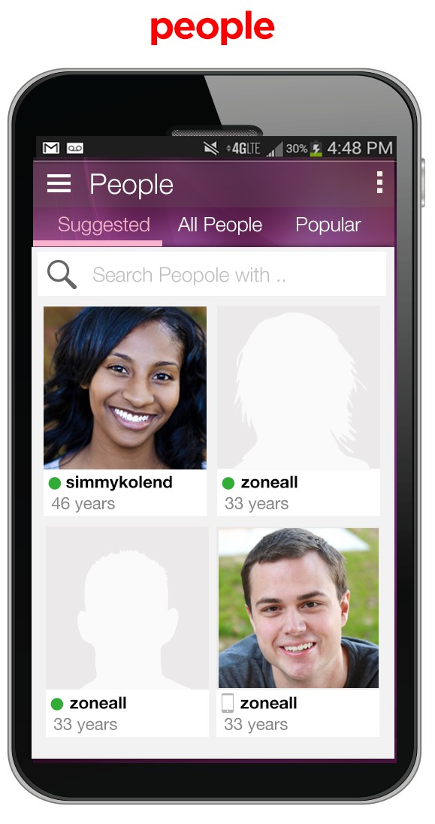

**Milestone 4:**

* Develop the people section.
* Design the People page to suit the above design.
* This section will be divided into 3 parts, including suggested, all people and popular.
* First, create the algorithm to store all registered users in the "All People" section.
* Second, setup and create algorithm to show suggested section, maybe it could be set as users's friends of friends.
* Basically, suggested and popular section can be combined, so either use popular or suggested. The algorithm for both would be the same.
* This milestone would cost **$ 380 (App)** + **$ 360 (Server side)** and it would take around **7-12** **days** time.

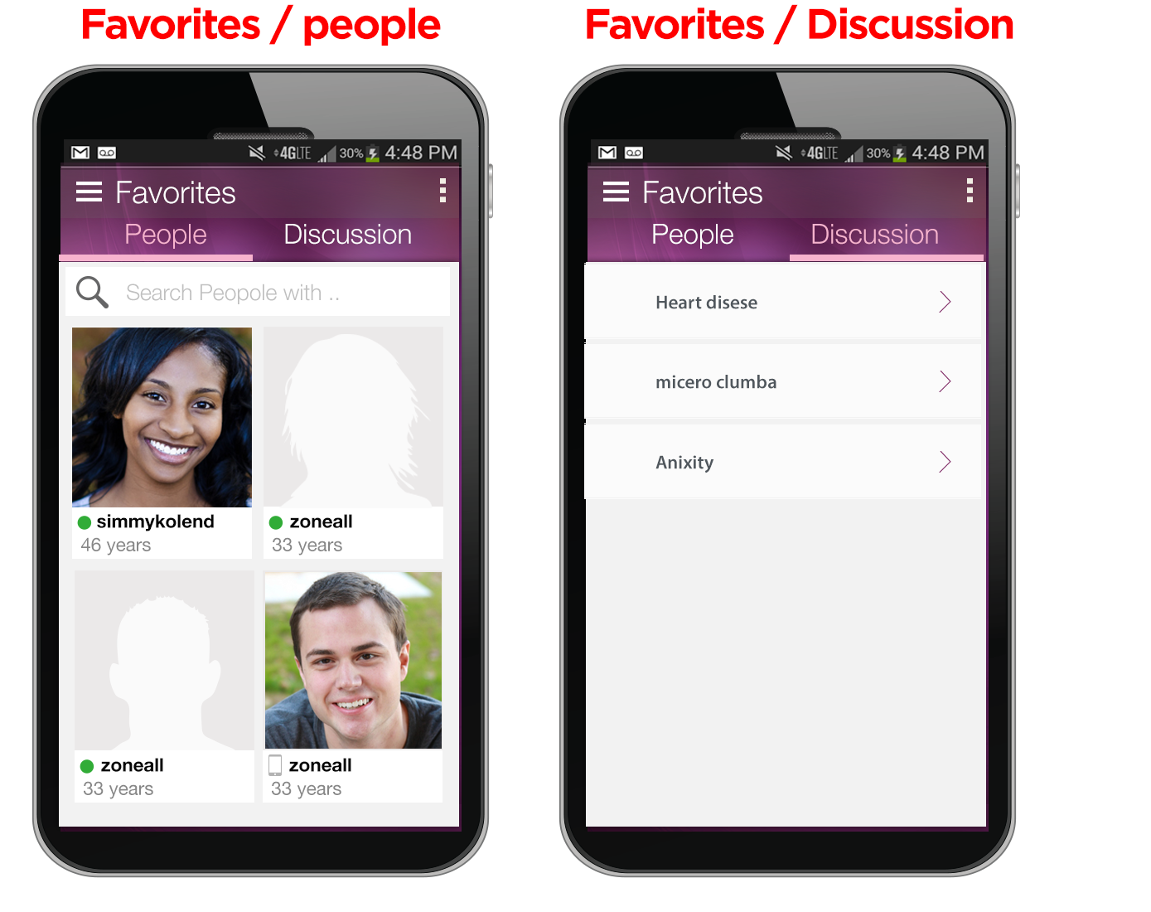

**Milestone 5:**

* Develop the Favorite section.
* Design the Favorite page to suit the above design.
* The favorite section will be divided into 2 parts, including favorite people and favorite discussion.
* Link the Health Discussion Page and People Page together with this favorite page and setup algorithm to work out the relationship among them.
* This milestone would cost **$ 350 (App)** + **$ 360 (Server side)**and it would take around **6-8days** time.

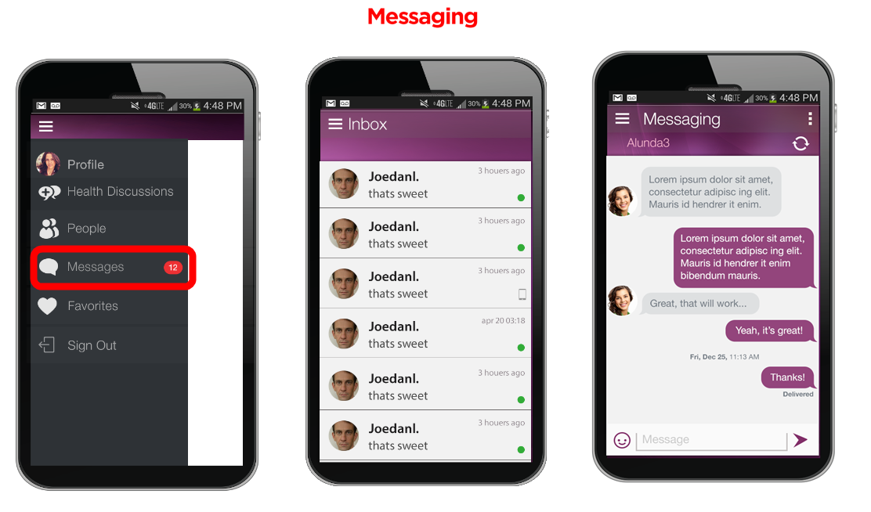

**Milestone 6:**

* Develop the Messaging and Chat section.
* Design this Inbox page and chatting page to suit the above design.
* Create the function of chat message inbox for user to receive messages from others.
* Setup and create the chatting function using Chat API and backend server (Amazon).
* Apply and implement function into the profile "message" button for opening this chatting page.
* Develop the algorithm to hold messages from all people.
* This milestone would cost **$ 420** (**App)+** **$ 630 (Server side)**and it would take around **12-15** **days** time.

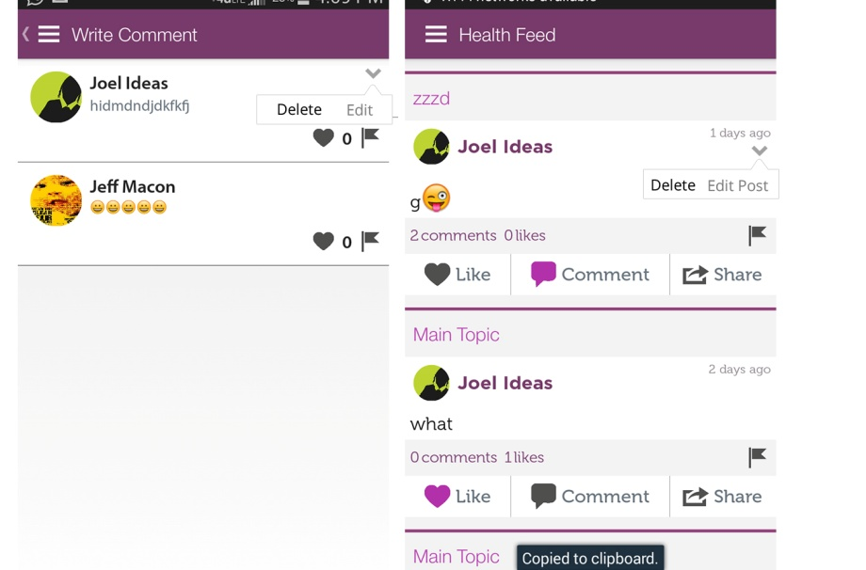 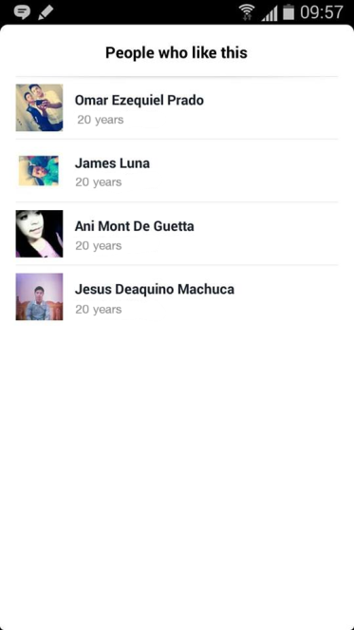

**Milestone 7:**

* Develop the delete and edit post/comment section.
* Design the page to suit the above design.
* Create edit functions on server(for post / comment).
* Create delete functions on server(for post / comment).
* Develop and add webservice for communicating between app and server for the edit and delete function.
* Change and edit UI in the feed / post / comment.
* Add a new function to see and check who like the post. (Click on "Like" text in the post to open the people like page)
* Design new UI for displaying the people who like the post.
* Develop new webservice and server for the fetching people who like the post and back to the app for showing.
* Create function to navigate the page to user's profile page when click on the selected user in "people like" page.
* This milestone would cost **$ 400(App)** **+** **$ 400(Server side)** and it would take around **7-10** **days** time.

**7) Ownership of Intellectual Property**

To the extent that Infinite Will Studio has given payment of compensation to Chen Wu Xian (Developer) as provided in this Agreement, Infinite Will Studio hereby assigns and obtains all rights, title, and interest in any intellectual property (all app graphics, app coding and copyright) under this Agreement.

**8) Payment to Developer**

Payment will be released to the Developer (Chen) through odesk platform once he completed each milestone upon delivering and submit/send the source code to the client (Infinite Will Studio/Jeffrey).

IN WITNESS WHEREOF, the parties have executed this Project Agreement on effective date stated on the signature below.

**Infinite Will Studio (Client)**

..........................................

JEFFREY CHIN

Date: 9 July 2014

**Apps Developer**

.........................................

Chen Wu Xian

Date: 9 July 2014